Chapter 6: Indices and surds

Test A (40 marks)

Name: ___________________________________

Part A – Multiple-choice (10 marks)

1 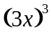 in expanded form is:

A B 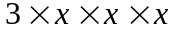 C 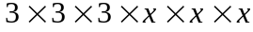

D 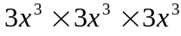 E 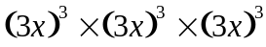

2 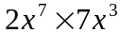 is equivalent to:

A 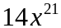 B 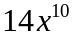 C 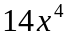

D 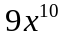 E 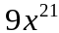

3 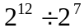 is equal to:

A 4 B 8 C 16

D 25 E 32

4 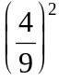 is equal to:

A 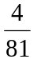 B 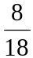 C 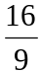

D 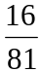 E 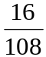

5 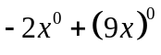 simplifies to:

A −2 B −1 C 0

D 2 E 7
6 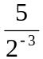 is equal to:

A 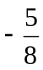 B C 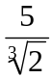

D 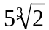 E 40

7 The number of significant figures given in 0.07309 is:

A two B three C four

D five E six

8 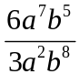 simplifies to:

A 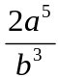 B 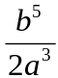 C 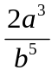

D 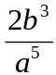 E 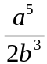

9 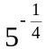 can be written as:

A 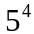 B 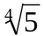 C

D 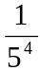 E 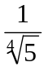

10 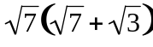 is equal to:

A 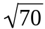 B 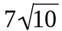 C 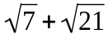

D 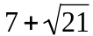 E 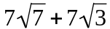

Part B – Short-answer (17 marks)

1 a Express each of the following in index form.

i 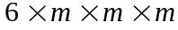 ii 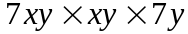

________________________________ _____________________________________
b Write 100 as a product of prime factors in index form.

__________________________________________________________________________________

(½ + ½ + 1 = 2 marks)

2 Simplify each of the following.

a 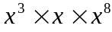 b 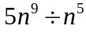

_______________________________ __________________________________
c 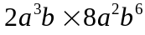 d 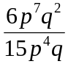

_______________________________ __________________________________

_______________________________ __________________________________

(½ + ½ + 1 + 1 = 3 marks)

3 Simplify each of the following.

a 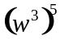 b 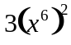

_______________________________ __________________________________

c 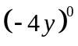 d 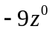

_______________________________ __________________________________

(4 × ½ = 2 marks)

4 Simplify each of the following.

a 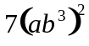 b 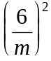
_______________________________ __________________________________

_______________________________ __________________________________

c 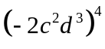 d 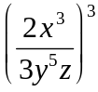

_______________________________ __________________________________

_______________________________ __________________________________
(½ + ½ + 1 + 1 = 3 marks)

5 Express each of the following using positive indices only.

a 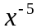 b 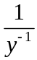
_______________________________ __________________________________

_______________________________ __________________________________
c 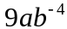 d 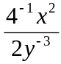
_______________________________ __________________________________

_______________________________ __________________________________

(½ + ½ + 1 + 1 = 3 marks)

6 Evaluate each of the following.

a 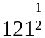 b 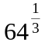

_______________________________ __________________________________

_______________________________ __________________________________

(1 + 1 = 2 marks)

7 Simplify each of the following.

a 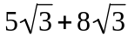 b 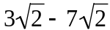

_______________________________ __________________________________

_______________________________ __________________________________

c 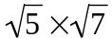 d 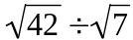

_______________________________ __________________________________

_______________________________ __________________________________

(4 × ½ = 2 marks)

Part C – Extended-response (13 marks)

1 Simplify each of the following using a combination of index laws. Express each answer using positive indices only.

a 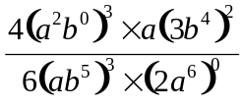 b 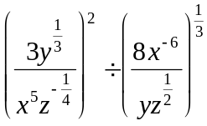

_______________________________ __________________________________

_______________________________ __________________________________

_______________________________ __________________________________

_______________________________ __________________________________

(2 + 3 = 5 marks)

2 a i The diameter of a nitrogen atom is 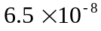 mm. Write this
measurement in decimal form.

_________________________________________________________________________

ii The diameter of a sodium atom is 0.00000018 mm. Write this measurement using scientific notation.

_________________________________________________________________________

iii What is the difference in the diameter of a nitrogen atom and a sodium atom? Write your answer using scientific notation.

_________________________________________________________________________

_________________________________________________________________________
b i The volume of the Moon is 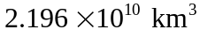. Write this measurement in decimal form.

_________________________________________________________________________

ii The volume of Earth is 1083 billion cubic kilometres; that is,
1 083 000 000 000 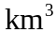. Write this measurement using scientific notation.

_________________________________________________________________________

iii What proportion of the Earth’s volume is the Moon? Write your answer using scientific notation and rounding to three significant figures.

_________________________________________________________________________

(1 + 1 + 2 + 1 + 1 + 2 = 8 marks)

